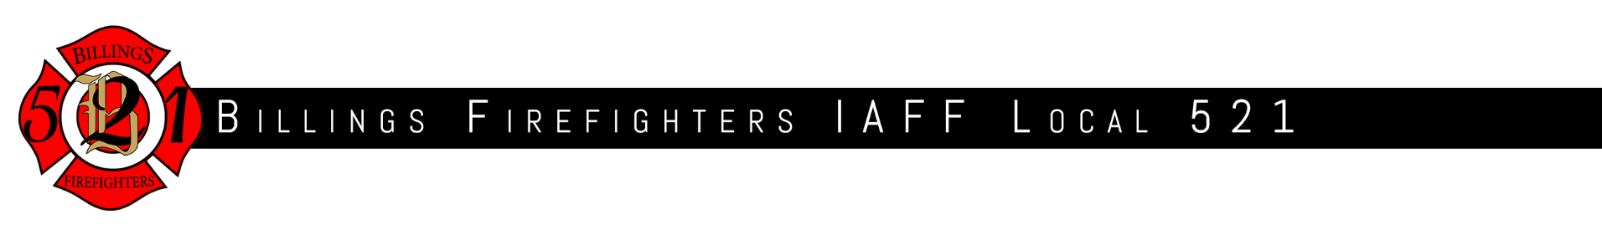

Questionnaire for Billings 2025 City Council Election.

The members of the Billings Firefighters Union, IAFF Local 521, are committed to protecting the lives, property, and well-being of our community. As we consider endorsements for the upcoming city council election, we are seeking your positions on issues that directly affect public safety, emergency response, firefighter health and wellness, and the future of Billings.  
  
Please respond to the following questions as thoroughly as possible. Your answers will help our membership make informed decisions about who will best support the citizens of Billings and the men and women who serve them.

1. Please provide a brief bio.

Billings homeowner 32 years. Commissioner, Mt Public Service Commission, 2017-25.@ children,3 grand children, 1 great grandson.

1. What made you want to run for city council? Desire to serve. Love to get involved and listen to all “sides” of an issue. Feel capable of coming to good decision.
2. What is your leadership style and how do you intend to bring a consensus to the council? I get all sorts of information from various knowledgeable sources. My comfort and experience lies in listening without prejudging and collaborating with my peers in respectful manner. I do, however, am adept at forming an informed decision and, if need be, to defend it. Use logic and grace at all times.
3. What do you see as the role and/or function of city government? The principal responsibility of city government is public safety, with emphasis on police and fire. The city owns, on our behalf, buildings, land, streets, infrastructure, etc. The time honored way of balancing budgets of deferring maintenance is the most expensive way to operate. Balancing these needs requires thoughtful but deep inquiries.
4. What is the number one issue facing Billings for the next city council, and how do you intend to address it? Finding a way to pay for all these basic needs (above) with limited resources, currently limited to property taxes, seems to be the biggest issue because we can do nothing that doesn’t have a cost attached.
5. How would you determine and consider the agendas of other council members to be the most productive and prioritize the conflicting demands of Billings?
6. Interesting question. I have attended, in person, all but 2 council meetings since February and have enjoyed noticing the contributions of the current council. Scott A seems to be the most thoughtful, Jennifer is the most eloquent and concise representative of conservative thought (she is really good!), Neece is the most detail driven, Boyette is a nice guy and the others do not play as major a role in these meetings. Kennedy’s contributions from his time on the county commission are helpful
7. How would you work with other entities to balance asks of the public for funding through levies and bonds? This process is in great need of revision. There are so many citizens who, I am sure, support items up for vote but actually vote no due to the increased property taxes which they simply cannot afford without making it necessary for them to leave their house. This requires state revision of tax sources, I strongly favor REAL and PERMANENT property tax relief. Perhaps a property tax freeze until the house is sold with financial infilling from the state until housing sales go full circle and catch up thus makinf local governments whole. Perhaps some formula of property tax reduction with a sales tax of local taxing authority would achieve desired solution. This wold absolutely require changes in our constitution.
8. What do you see as the role of the Union in representing the 144 members of Local 521? Keep city council members informed with all facts and remain engaged makes the most sense to me. Unfortunately, I have no collective bargaining experience to answer more completely. Give me your best and I’ll do the same.
9. Currently Fire Station 5 is undergoing a renovation that is long overdue. There are four other stations that need considerable renovations and a growing need for a new station to support growth. What is your stance on maintaining what is currently in use versus building new stations? It makes abundant sense to keep tools you currently have in good working order. Deferred maintenance, as I have said, is the most expensive options. Having said that, I am not aware of the research to support the need for a new station, Deploying incentives to encourage developers to build within the existing city limits seems to bring fire protection closer to stations which seems to me would reduce response times and allow the dept to be more effective. Right?
10. The men and women of Local 521 currently respond to about 18,000 to 20,000 calls for service each year. Departments throughout the nation that respond to a similar number of calls have between 200 and 250 members taking those calls. Currently L521 has 144 members. What do you see as solutions to add staffing? It all comes down to money.
11. Firefighters face significant risks from cancer, PTSD, and other occupational hazards. How would you support initiatives to improve firefighter health and wellness programs?

It seems that this is a role for the MT legislature. I don’t know if the city has the ability to handle this in just a local area but would need a much wider coverage covering all depts, municipal, county and volunteer. As to how this could be improved, I knoiw that this has been argued in Helena but I do not know where it stands now.

1. How will you approach contract negotiations with Local 521 if elected to city council? I will do my best to maintain a well equipped and well motivated fire force.
2. How would you support community risk reduction initiatives such as fire prevention education, wildfire preparedness, and public health partnerships? Absolutely!

Thank you for your time and thoughtful responses. Your answers will be shared with our membership as we consider our endorsement. Please return your completed questionnaire to Local 521 by September 1st, 2025 at 5p.m.